ECN PROJECT #1 SPECTRUM ANALYZER 17 October 2021 WN2A

References:
Progress_Report_Project1_10Oct2021
Performance Report 25September 2021
Project #1 Spectrum Analyzer Version 3.0.0.00 RF Assembly gEDA documents from github

This ECN is applied against Project #1 Spectrum Analyzer Version 3.0.0.00 RF Assembly. It is based on measured observations on a Version 2.0.0.00 RF Assembly. It is believed that all items listed in this ECN are necessary for the anticipated performance of Version 3.0.0.00 RF Assembly, but this will only be known upon Version 3.0.0.00 RF Assembly completion and test. Some PCB modifications made to Version 2.0.0.00 were not included in this ECN as they were already part of the Version 3.0.0.00 design.

I. SPECTRUM ANALYZER TOP ASSEMBLY

a) DNI U104,R113,L101,C124,R109. Also remove these components from any existing assemblies.

b) Delete C127, C123. (p/n 530L104KT16T).
Use a Zero Ohm Chip (p/n CRCW06030000Z0EBC) at C127 and C123.

c) Attach R108,R110 300 ohm 0402. p/n CRCW0402300RFKEDC

d) Attach R111 18 ohm 0402. p/n CRCW040218R0JNED

e) Remove U102 MCL p/n SIM-83+. Replace with MCL p/n SIM-U742MH. Part has same outline.

f) Remove U101 p/n ERA-2SM+. Replace with MCL p/n GVA-123+. Modify PCB as required to accommodate the different package of the new part, as the old part is in the SOT-86 package and the new part is in the SOT-89 package. See diagrams Figure 1 and Figure 2

g) REFERENCE DESIGNATORS R104 and R105.
FROM:51 ohms p/n CRCW080551R0FKEA
TO: 24 ohms, p/n CRCW080524R0FKEA.

h) To REF DESIGNATOR U201: Change
FROM: p/n ERA-2SM+
TO: MAR-8ASM+.

i) To REF DESIGNATORS R202 and R203 Change
FROM: 110 ohms 1206 p/n CRCW1206110RFKEA
TO: 51 ohms 1296 p/n CRCW120651R0JNEA

Figure 1: U101 FROM:
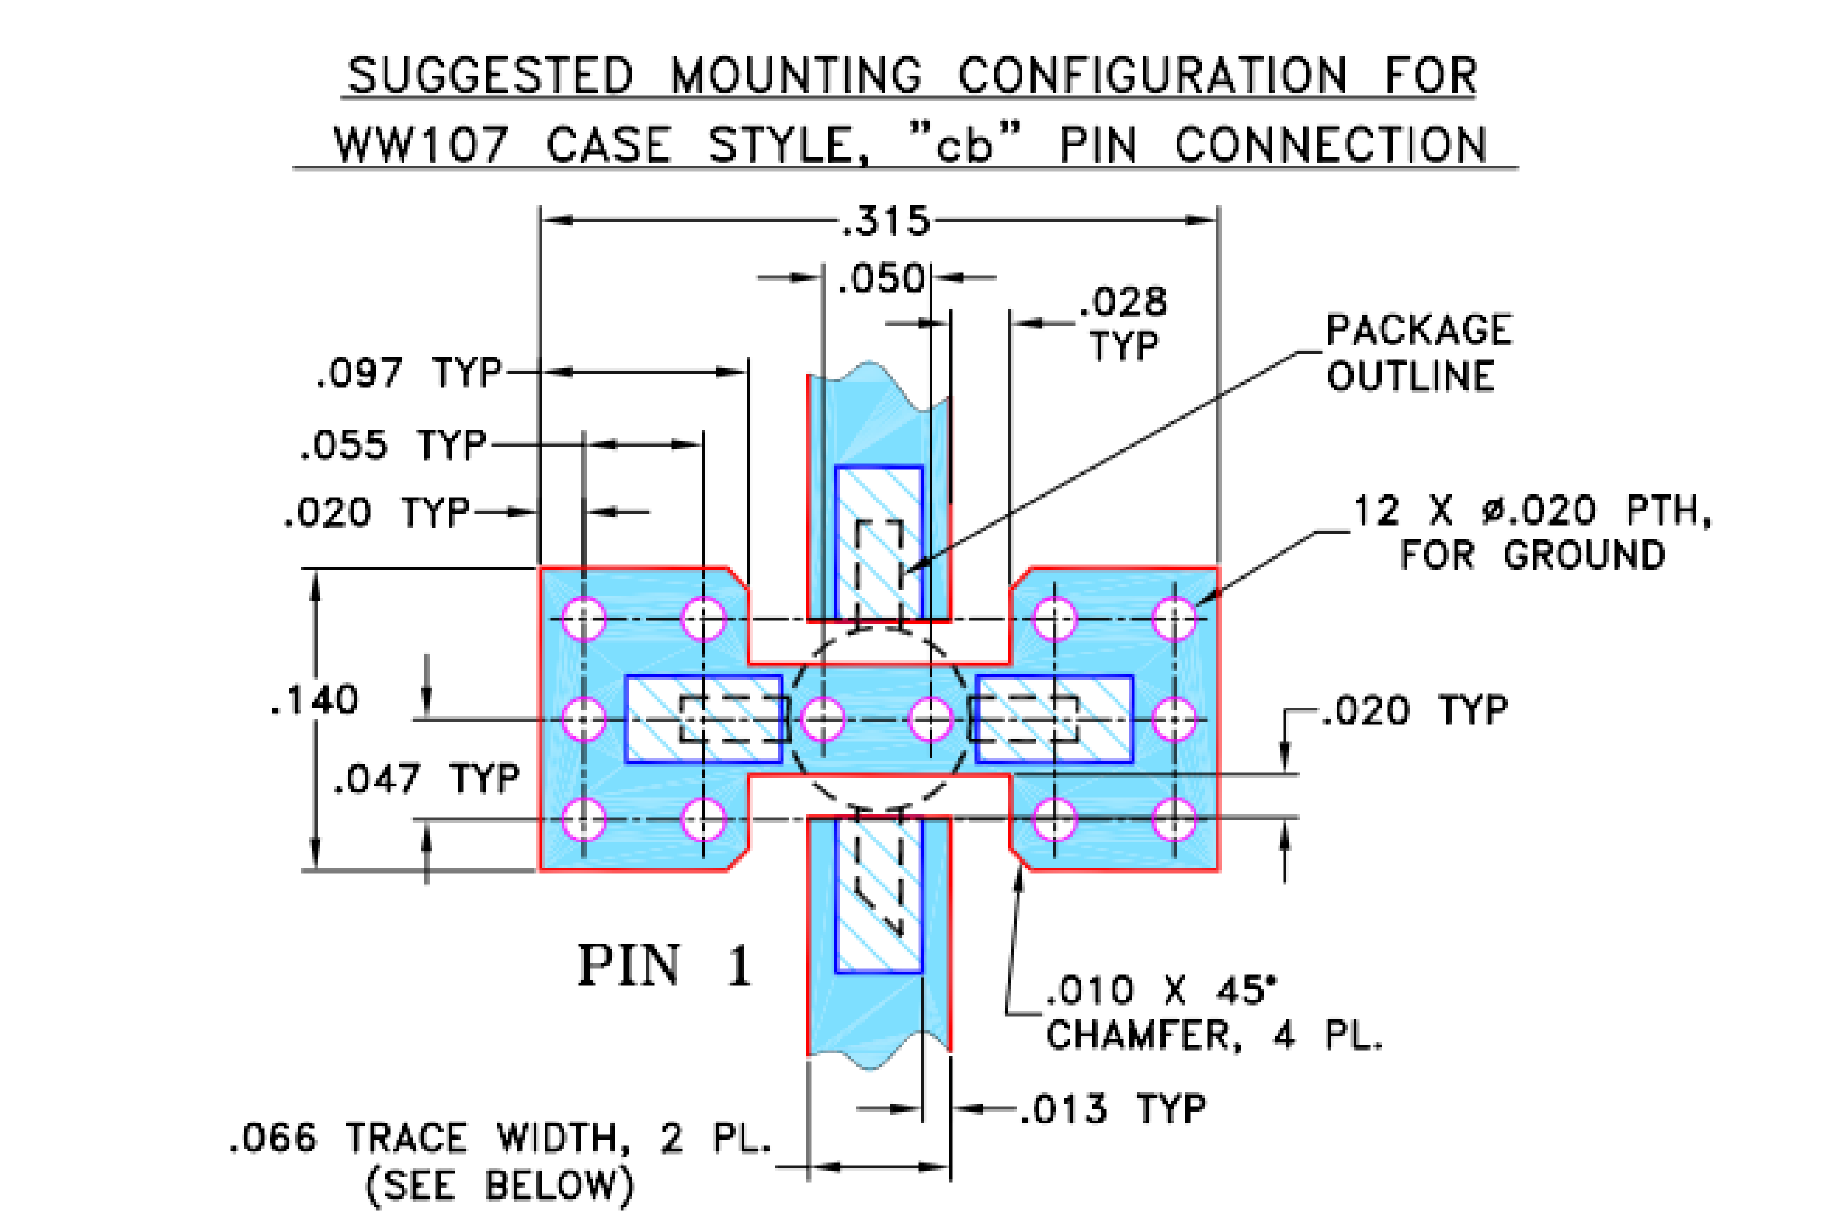
Figure 2: U101 TO:
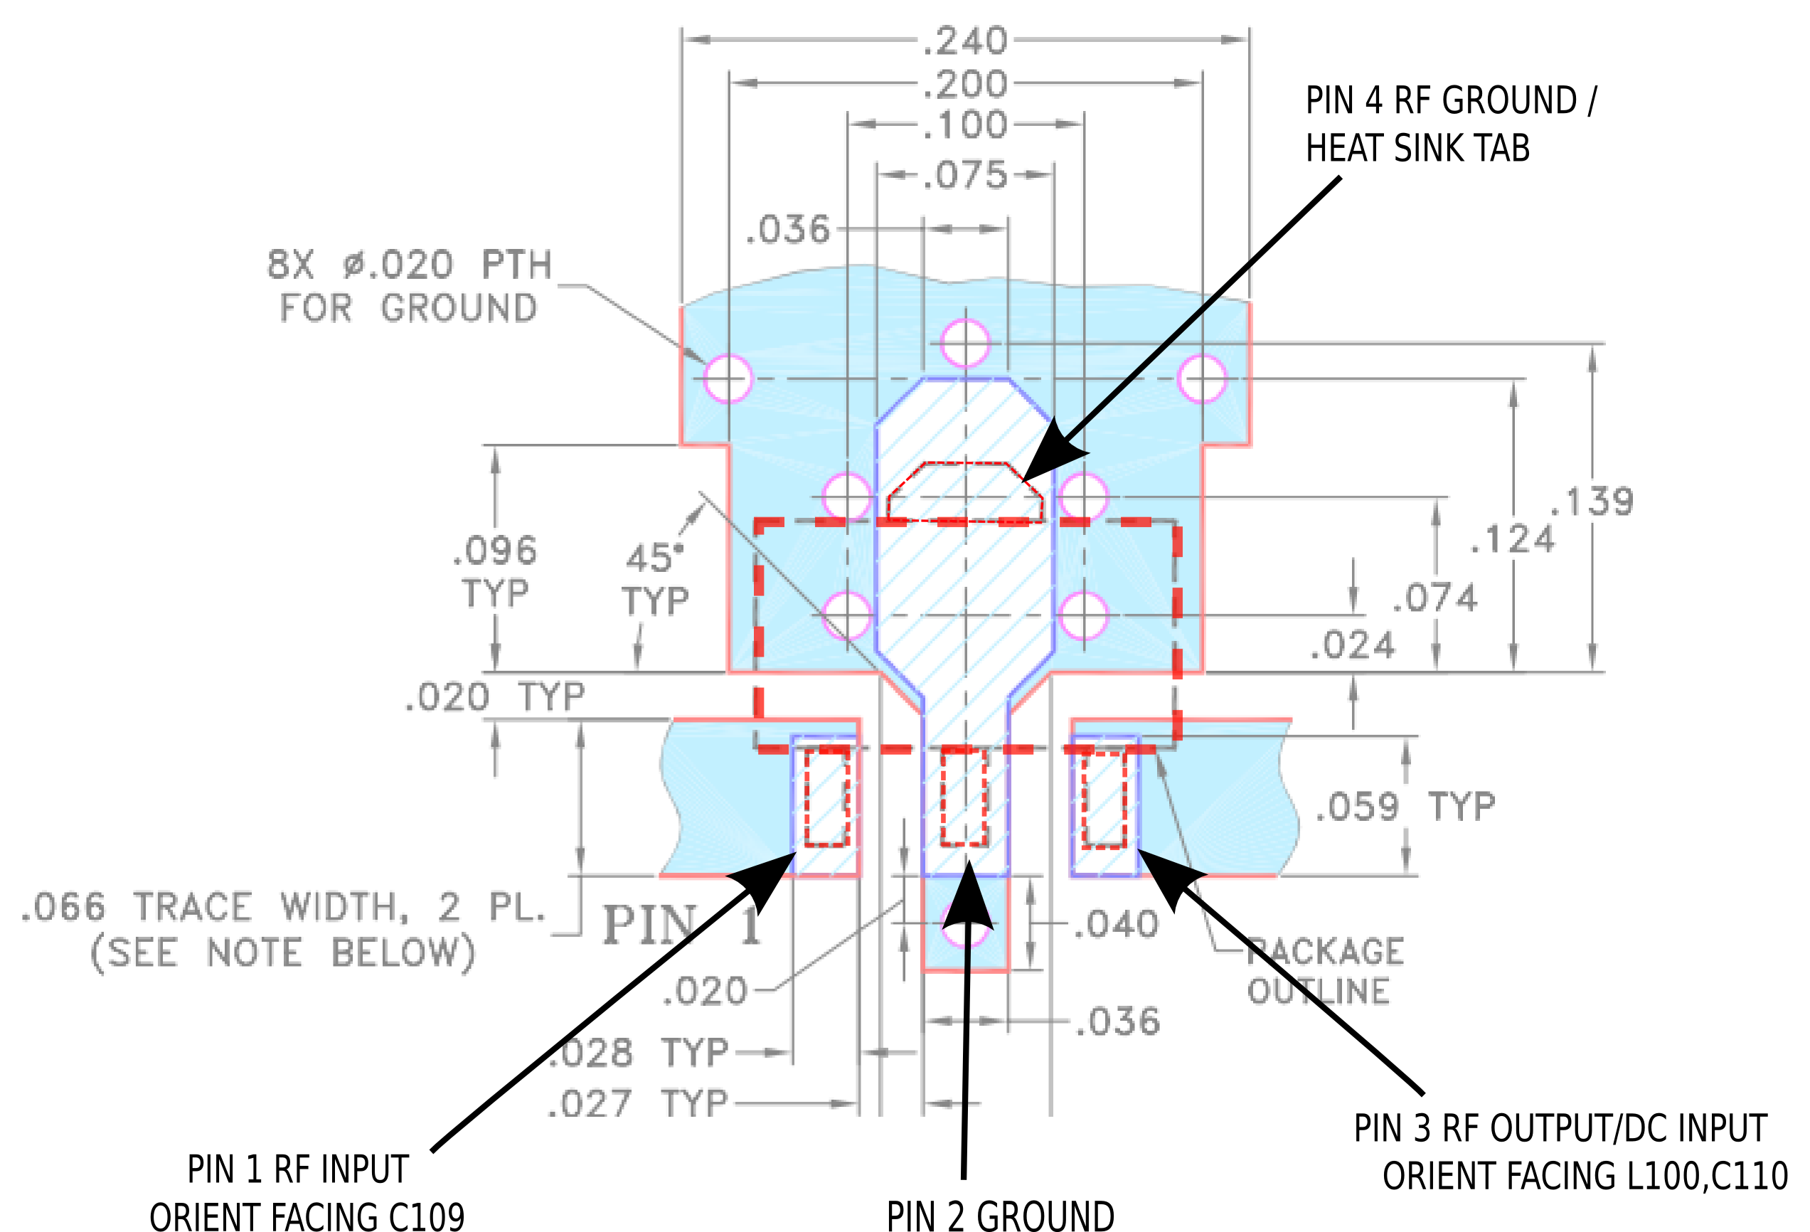
II. SPECTRUM ANALYZER BOTTOM ASSEMBLY

a) To REF DESIGNATORS R300,R301,R307 and R309 Change
FROM: 110 ohms 1206 p/n CRCW1206110RFKEA
TO: 51 ohms 1206 p/n CRCW120651R0JNEA

b) PCB MODIFICATION: 45MHz Log Amp improvement. Insert Low-Pass Filter -Pi Type
See Figure 3: Mark-Up of Version 3.0.0.00 Layout and Figure 4: Photo of Version 2.0.00 modification below.

1 | Delete L303. At this location ‘A’ attach new 30pF Capacitor Murata GCM1555C1H300JA16D
2 | Delete C317, At this location ‘B’ attach new 390nH Inductor Coilcraft 0805CS-391XJLB [1]  This inductor may use either C317 or C325 locations.
3 | From the node connecting the new Inductor in 1) above and C318 to Ground, attach new 120 pF capacitor at location ‘C’ Murata GRM1555C1H121GA01D

NOTES:
[1] If this part is too large to fit, use 0603CS-R39XJLW. The 0805 part does fit on Version 2.0.0.00 PCB’s, but could be too large to fit on Version 3.0.0.00 PCB’s,

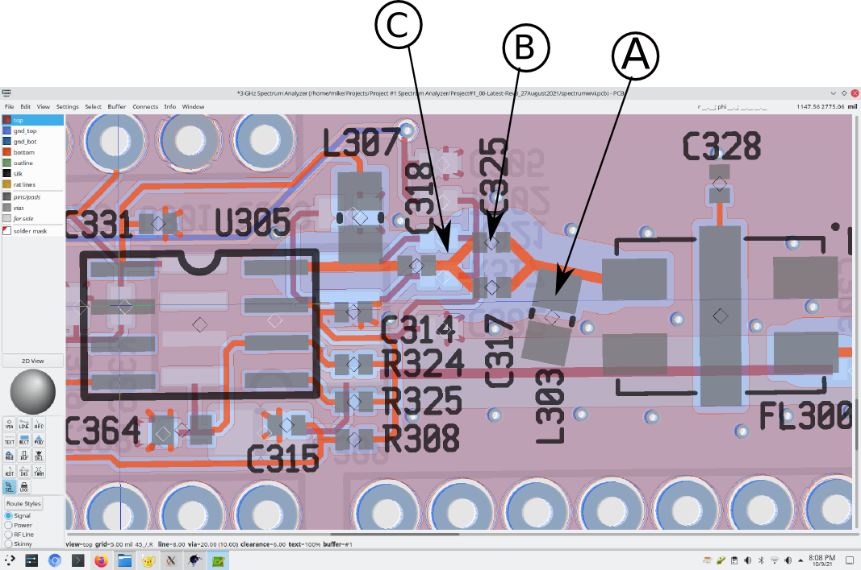
Figure 3: Version 3.0.00 Mark-Up:

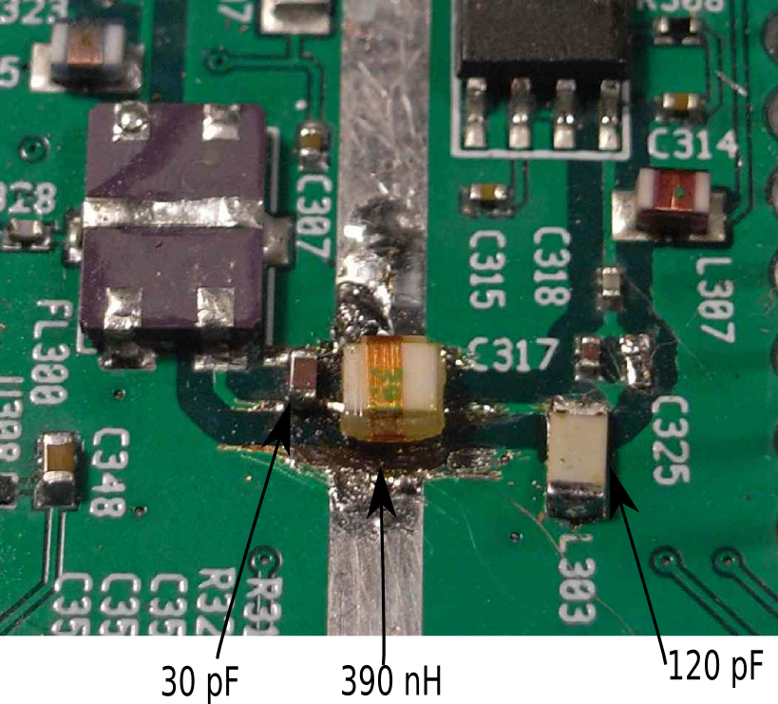
Figure 4: Photo of Version 2.0.00 modification (for reference only)

